|  |
| --- |
| CAP 4621 |
| Final Report |
| Numbrix |
|  |
| **Carlos Vasquez** |
| **11/23/2013** |

|  |
| --- |
|  |

Table of Contents

**I.** **Description of Game** 2

**II.** **Description of Implementation Approach** 2

**III.** **Description of Programs, Procedures, Methods and Variables** 3

Package numbrixgame 3

Package numbrixgame.gui 5

Package numbrixgame.gui.leftdisplay 10

Package numbrixgame.gui.menubar 14

Package numbrixgame.system 17

Package numbrixgame.system.solver 29

**I.** **Flowchart** 44

**i.** **General Overview** 44

**ii.** **Solver** 45

**iii.** **Solvers Constraint Satisfaction Search** 46

**iv.** **Constraint Search’s Search Method** 47

**v.** **Heuristic Search’s Search mehtod** 48

**II.** **UML** 49

**i.** **numbrix** 49

**i.** **gui** 50

**a.** **leftdisplay** 50

**b.** **menubar** 51

**ii.** **Numbrix.System** 51

**i.** **solver** 52

**II.** **Description of Intelligence Implemented** 53

**i.** **Snake** 53

**ii.** **Solver** 53

**iii.** **Constraint Search** 54

**iv.** **Heuristic Search** 55

**III.** **What I Would Have Done Differently** 56

1. Description of Game

The game implemented is called Numbrix. The goal of the game is to fill out a N by N grid with numbers between one and $N×N$ and each number can only be used once. The player is given this grid with some of the cells already populated with a number. From there, the player must attempt to fill in the entire grid by finding every increasingly or decreasingly consecutive number in the vertical or horizontal directions (no diagonal directions) from a cell. Once the player completes the grid, the player should be able to start from the cell with value one and trace a non-terminating line of consecutive numbers in a non-diagonal direction up until the line reaches the number $N×N$.

1. Description of Implementation Approach

Considering the competitive nature of the project, there was a focus on speed and memory. The goal was to solve the Numbrix grid quickly while consuming as little resources as possible. Due to the use of recursive objects in the program, I ended up utilizing multiple static variables to help reduce the memory that needs to be consumed when solving the grid.

1. Description of Programs, Procedures, Methods and Variables

|  |  |  |
| --- | --- | --- |
| Package Summary | | Page |
| **numbrixgame** |  | 3 |
| **numbrixgame.gui** |  | 5 |
| **numbrixgame.gui.leftdisplay** |  | 10 |
| **numbrixgame.gui.menubar** |  | 14 |
| **numbrixgame.system** |  | 17 |
| **numbrixgame.system.solver** |  | 29 |

Package numbrixgame

|  |  |  |
| --- | --- | --- |
| Class Summary | | Page |
| **numbrix** | Numbrix will be the "main" of the project. | 3 |

Class numbrix

**numbrixgame**

java.lang.Object

**numbrixgame.numbrix**

Direct Known Subclasses:

SearchTest

public class **numbrix**

extends Object

Numbrix will be the "main" of the project. It will construct the components needed to run and then run the program.

|  |  |
| --- | --- |
| Field Summary | |
| protected static GUI | **gui** |
| protected static NumbrixSystem | **system**  Class Attributes |

|  |
| --- |
| Constructor Summary |
| **numbrix**() |

|  |  |
| --- | --- |
| Method Summary | |
| static GUI | **gui**()  Returns gui |
| protected static void | **initializeSystem**()  Initializes system |
| protected static void | **initializeUI**()  Initializes gui |
| static void | **main**(String[] args)  Class Methods |
| static NumbrixSystem | **system**()  Returns system |

Field Detail

system

protected static NumbrixSystem **system**

Class Attributes

gui

protected static GUI **gui**

Constructor Detail

numbrix

public **numbrix**()

Method Detail

main

public static void **main**(String[] args)

Class Methods

system

public static final NumbrixSystem **system**()

Returns system

**Returns:**

system

gui

public static final GUI **gui**()

Returns gui

**Returns:**

gui

initializeUI

protected static final void **initializeUI**()

Initializes gui

initializeSystem

protected static final void **initializeSystem**()

Initializes system

Package numbrixgame.gui

|  |  |  |
| --- | --- | --- |
| Class Summary | | Page |
| **BottomDisplay** | BottomDisplay will take care of the bottom display in the GUI. | 5 |
| **GUI** | GUI will be the gui that acts as the "view" for Numbrix | 5 |
| **HistoryDisplay** | HistoryDisplay will display the history of the game | 7 |
| **Table** | Table will be the table created that will act as the UI for Numbrix. | 8 |

Class BottomDisplay

**numbrixgame.gui**

java.lang.Object

java.awt.Component

java.awt.TextComponent

java.awt.TextArea

**numbrixgame.gui.BottomDisplay**

All Implemented Interfaces:

Accessible, ImageObserver, MenuContainer, Serializable

public class **BottomDisplay**

extends TextArea

BottomDisplay will take care of the bottom display in the GUI. This will contain a text box that will be used to display messages to the user.

|  |  |
| --- | --- |
| Field Summary | |
| private static long | **serialVersionUID**  Class Cosntants |
| private static String | **START** |

|  |
| --- |
| Constructor Summary |
| **BottomDisplay**()  Class Methods |

Field Detail

serialVersionUID

private static final long **serialVersionUID**

Class Cosntants

START

private static final String **START**

Constructor Detail

BottomDisplay

public **BottomDisplay**()

Class Methods

Class GUI

**numbrixgame.gui**

java.lang.Object

java.awt.Component

java.awt.Container

java.awt.Window

java.awt.Frame

javax.swing.JFrame

**numbrixgame.gui.GUI**

All Implemented Interfaces:

Accessible, ImageObserver, MenuContainer, RootPaneContainer, Serializable, TransferHandler.HasGetTransferHandler, WindowConstants

public class **GUI**

extends JFrame

GUI will be the gui that acts as the "view" for Numbrix

|  |  |
| --- | --- |
| Field Summary | |
| private BottomDisplay | **bottom** |
| private static int | **DEFAULT_CLOSE_OP** |
| static int | **HEIGHT** |
| private HistoryDisplay | **history** |
| private LeftDisplay | **left** |
| private static String | **NAME** |
| private static long | **serialVersionUID**  Class Constants |
| private Table | **table**  Class Attributes |
| static int | **WIDTH** |

|  |
| --- |
| Constructor Summary |
| **GUI**()  Class Methods |

|  |  |
| --- | --- |
| Method Summary | |
| void | **addLeftDisplay**(NumbrixSystem.Player playerType)  Creates the LeftDisplay to be used given the playerType |
| void | **addTable**(int tableSize, boolean[][] staticData, Integer[][] startData)  Overrides the current table with the startData and staticData |
| void | **changeHistory**(String newHistory)  Change history to show the provided text |
| Table | **getTable**()  Returns table |
| private void | **initializeUI**()  Creates the basic UI |
| void | **printMessage**(String message)  Sets the message as the text for bottom |
| void | **removeLeftDisplay**()  Removes the contents in left and then removes left |
| void | **removeTable**()  Removes the table from GUI |
| void | **revalidateTable**()  Renders the table |

Field Detail

serialVersionUID

private static final long **serialVersionUID**

Class Constants

NAME

private static final String **NAME**

WIDTH

public static final int **WIDTH**

HEIGHT

public static final int **HEIGHT**

DEFAULT_CLOSE_OP

private static final int **DEFAULT_CLOSE_OP**

table

private Table **table**

Class Attributes

bottom

private BottomDisplay **bottom**

left

private LeftDisplay **left**

history

private HistoryDisplay **history**

Constructor Detail

GUI

public **GUI**()

Class Methods

Method Detail

printMessage

public void **printMessage**(String message)

Sets the message as the text for bottom

**Parameters:**

message - the message being set

addTable

public void **addTable**(int tableSize,  
                     boolean[][] staticData,  
                     Integer[][] startData)

Overrides the current table with the startData and staticData

**Parameters:**

tableSize - the size of the table

staticData - the non-modifiable cells

startData - the data to populate

removeTable

public void **removeTable**()

Removes the table from GUI

revalidateTable

public void **revalidateTable**()

Renders the table

addLeftDisplay

public void **addLeftDisplay**(NumbrixSystem.Player playerType)

Creates the LeftDisplay to be used given the playerType

**Parameters:**

playerType - the type of player (COMPUTER or HUMAN)

removeLeftDisplay

public void **removeLeftDisplay**()

Removes the contents in left and then removes left

changeHistory

public void **changeHistory**(String newHistory)

Change history to show the provided text

**Parameters:**

newHistory - the text to be shown in history

initializeUI

private final void **initializeUI**()

Creates the basic UI

getTable

public Table **getTable**()

Returns table

**Returns:**

table

Class HistoryDisplay

**numbrixgame.gui**

java.lang.Object

java.awt.Component

java.awt.TextComponent

java.awt.TextArea

**numbrixgame.gui.HistoryDisplay**

All Implemented Interfaces:

Accessible, ImageObserver, MenuContainer, Serializable

public class **HistoryDisplay**

extends TextArea

HistoryDisplay will display the history of the game

|  |  |
| --- | --- |
| Field Summary | |
| private static long | **serialVersionUID**  Class Cosntants |

|  |
| --- |
| Constructor Summary |
| **HistoryDisplay**()  Class Methods |

|  |  |
| --- | --- |
| Method Summary | |
| void | **setText**(String text) |

Field Detail

serialVersionUID

private static final long **serialVersionUID**

Class Cosntants

Constructor Detail

HistoryDisplay

public **HistoryDisplay**()

Class Methods

Method Detail

setText

public void **setText**(String text)

**Overrides:**

setText in class TextComponent

Class Table

**numbrixgame.gui**

java.lang.Object

java.awt.Component

java.awt.Container

javax.swing.JComponent

javax.swing.JTable

**numbrixgame.gui.Table**

All Implemented Interfaces:

Accessible, CellEditorListener, EventListener, ImageObserver, ListSelectionListener, MenuContainer, RowSorterListener, Scrollable, Serializable, TableColumnModelListener, TableModelListener, TransferHandler.HasGetTransferHandler

public class **Table**

extends JTable

Table will be the table created that will act as the UI for Numbrix.

|  |  |
| --- | --- |
| Field Summary | |
| private static long | **serialVersionUID**  Class Constants |
| private boolean[][] | **startData**  Class Attributes |

|  |
| --- |
| Constructor Summary |
| **Table**(int tableSize, boolean[][] staticData, Integer[][] grid)  Class Methods |

|  |  |
| --- | --- |
| Method Summary | |
| Integer[][] | **getGrid**()  Returns a 2D array that represents the table |
| boolean | **isCellEditable**(int row, int column) |
| private void | **populate**(int tableSize, Integer[][] grid)  Populates the table with the given grid |
| void | **setValueAt**(Object value, int row, int column) |
| void | **setValueAt**(Object value, int row, int column, boolean modifyGrid) |

Field Detail

serialVersionUID

private static final long **serialVersionUID**

Class Constants

startData

private boolean[][] **startData**

Class Attributes

Constructor Detail

Table

public **Table**(int tableSize,  
             boolean[][] staticData,  
             Integer[][] grid)

Class Methods

Method Detail

isCellEditable

public boolean **isCellEditable**(int row,  
                              int column)

**Overrides:**

isCellEditable in class JTable

getGrid

public Integer[][] **getGrid**()

Returns a 2D array that represents the table

**Returns:**

a 2D array that represents the table

setValueAt

public void **setValueAt**(Object value,  
                       int row,  
                       int column)

**Overrides:**

setValueAt in class JTable

setValueAt

public void **setValueAt**(Object value,  
                       int row,  
                       int column,  
                       boolean modifyGrid)

populate

private void **populate**(int tableSize,  
                      Integer[][] grid)

Populates the table with the given grid

**Parameters:**

tableSize - the size of the table

grid - the grid that will populate the table

Package numbrixgame.gui.leftdisplay

|  |  |  |
| --- | --- | --- |
| Class Summary | | Page |
| **CompleteActionListener** | CompleteActionListener will populate the board with the correct solution as found by the Solver and update the history log with every move made by the solver to achieve the solution. | 10 |
| **ComputerActionListener** | Abstract class that will be used by the action listeners implemented when the computer is chosen as the player. | 10 |
| **FinishActionListener** | FinishActionListener will define the action listener to be used by the finish button. | 11 |
| **LeftDisplay** | LeftDisplay will create a toolbar on the left dislpay providing the player options. | 12 |
| **NextActionListener** | The NextActionListener will define the functionality of the Next button. | 12 |

Class CompleteActionListener

**numbrixgame.gui.leftdisplay**

java.lang.Object

numbrixgame.gui.leftdisplay.ComputerActionListener

**numbrixgame.gui.leftdisplay.CompleteActionListener**

All Implemented Interfaces:

ActionListener, EventListener

public class **CompleteActionListener**

extends ComputerActionListener

CompleteActionListener will populate the board with the correct solution as found by the Solver and update the history log with every move made by the solver to achieve the solution.

|  |
| --- |
| **Fields inherited from class numbrixgame.gui.leftdisplay.****ComputerActionListener** |
| grid, historyLog, logSize, next, solver, time |

|  |
| --- |
| Constructor Summary |
| **CompleteActionListener**(Solver solver)  Class Methods |

|  |  |  |
| --- | --- | --- |
| Method Summary | |  |
| void | **actionPerformed**(ActionEvent e) |  |

Constructor Detail

CompleteActionListener

public **CompleteActionListener**(Solver solver)

Class Methods

Method Detail

actionPerformed

public void **actionPerformed**(ActionEvent e)

**Specified by:**

actionPerformed in interface ActionListener

Class ComputerActionListener

**numbrixgame.gui.leftdisplay**

java.lang.Object

**numbrixgame.gui.leftdisplay.ComputerActionListener**

All Implemented Interfaces:

ActionListener, EventListener

Direct Known Subclasses:

CompleteActionListener, NextActionListener

abstract public class **ComputerActionListener**

extends Object

implements ActionListener

Abstract class that will be used by the action listeners implemented when the computer is chosen as the player.

|  |  |  |
| --- | --- | --- |
| Field Summary | |  |
| protected static Integer[][] | **grid** |  |
| protected static ArrayList<Log> | **historyLog** |  |
| protected static int | **logSize** |  |
| protected static int | **next**  Class Attributes |  |
| protected static Solver | **solver** |  |
| protected static String | **time** |  |

|  |  |
| --- | --- |
| Constructor Summary |  |
| **ComputerActionListener**(Solver solver, boolean init)  Class Methods |  |

Field Detail

next

protected static int **next**

Class Attributes

logSize

protected static int **logSize**

grid

protected static Integer[][] **grid**

historyLog

protected static ArrayList<Log> **historyLog**

time

protected static String **time**

solver

protected static Solver **solver**

Constructor Detail

ComputerActionListener

public **ComputerActionListener**(Solver solver,  
                              boolean init)

Class Methods

Class FinishActionListener

**numbrixgame.gui.leftdisplay**

java.lang.Object

**numbrixgame.gui.leftdisplay.FinishActionListener**

All Implemented Interfaces:

ActionListener, EventListener

public class **FinishActionListener**

extends Object

implements ActionListener

FinishActionListener will define the action listener to be used by the finish button. It should request from system a message that states the state of the grid and then return it to the player via the bottom text box.

|  |  |
| --- | --- |
| Constructor Summary |  |
| **FinishActionListener**() |  |

|  |  |  |
| --- | --- | --- |
| Method Summary | |  |
| void | **actionPerformed**(ActionEvent e)  Class Methods |  |

Constructor Detail

FinishActionListener

public **FinishActionListener**()

Method Detail

actionPerformed

public void **actionPerformed**(ActionEvent e)

Class Methods

**Specified by:**

actionPerformed in interface ActionListener

Class LeftDisplay

**numbrixgame.gui.leftdisplay**

java.lang.Object

java.awt.Component

java.awt.Container

javax.swing.JComponent

javax.swing.JToolBar

**numbrixgame.gui.leftdisplay.LeftDisplay**

All Implemented Interfaces:

Accessible, ImageObserver, MenuContainer, Serializable, SwingConstants, TransferHandler.HasGetTransferHandler

public class **LeftDisplay**

extends JToolBar

LeftDisplay will create a toolbar on the left dislpay providing the player options. The options provided will depend on the type of user (player or computer).

|  |  |  |
| --- | --- | --- |
| Field Summary | |  |
| private static long | **serialVersionUID**  Class Cosntants |  |

|  |  |
| --- | --- |
| Constructor Summary |  |
| **LeftDisplay**() |  |

|  |  |  |
| --- | --- | --- |
| Method Summary | |  |
| void | **initialize**(NumbrixSystem.Player playerType)  Creates the appropriate JButton(s) based on the playerType |  |
| private void | **initializeComputer**()  Creates a "NextMove" and a "Complete" button that will display the next move made by the solver or display the completed board and every move made by the solver (respectively) |  |
| private void | **initializeHuman**()  Creates a Finish button that will check the board for completeness and correctness |  |

Field Detail

serialVersionUID

private static final long **serialVersionUID**

Class Cosntants

Constructor Detail

LeftDisplay

public **LeftDisplay**()

Method Detail

initialize

public void **initialize**(NumbrixSystem.Player playerType)

Creates the appropriate JButton(s) based on the playerType

**Parameters:**

playerType - type of player (COMPUTER or HUMAN)

initializeHuman

private final void **initializeHuman**()

Creates a Finish button that will check the board for completeness and correctness

initializeComputer

private final void **initializeComputer**()

Creates a "NextMove" and a "Complete" button that will display the next move made by the solver or display the completed board and every move made by the solver (respectively)

Class NextActionListener

**numbrixgame.gui.leftdisplay**

java.lang.Object

numbrixgame.gui.leftdisplay.ComputerActionListener

**numbrixgame.gui.leftdisplay.NextActionListener**

All Implemented Interfaces:

ActionListener, EventListener

public class **NextActionListener**

extends ComputerActionListener

The NextActionListener will define the functionality of the Next button. It will allow the user to step through the Solvers steps to see the approach the Solver took to obtain the solution. It will update the history with the next step and update the BottomDisplay with the step count and completion time.

|  |  |  |
| --- | --- | --- |
| Field Summary | |  |
| private int | **totalMoves**  Class Attributes |  |

|  |
| --- |
| **Fields inherited from class numbrixgame.gui.leftdisplay.****ComputerActionListener** |
| grid, historyLog, logSize, next, solver, time |

|  |  |
| --- | --- |
| Constructor Summary |  |
| **NextActionListener**(Solver solver)  Class Methods |  |

|  |  |  |
| --- | --- | --- |
| Method Summary | |  |
| void | **actionPerformed**(ActionEvent e) |  |

Field Detail

totalMoves

private int **totalMoves**

Class Attributes

Constructor Detail

NextActionListener

public **NextActionListener**(Solver solver)

Class Methods

Method Detail

actionPerformed

public void **actionPerformed**(ActionEvent e)

**Specified by:**

actionPerformed in interface ActionListener

Package numbrixgame.gui.menubar

|  |  |  |
| --- | --- | --- |
| Class Summary | | Page |
| **FileMenu** | FileMenu will create the file menu that will be added to the menu tool bar | 14 |
| **Menubar** | Toolbar will create the toolbar to be used by Numbrix | 15 |
| **NewActionListener** | The ActionListener that will be used by the New Menu Item. | 15 |
| **ResetActionListener** | ResetActionListener will define what is to be done when Reset is clicked. | 16 |

Class FileMenu

**numbrixgame.gui.menubar**

java.lang.Object

java.awt.Component

java.awt.Container

javax.swing.JComponent

javax.swing.AbstractButton

javax.swing.JMenuItem

javax.swing.JMenu

**numbrixgame.gui.menubar.FileMenu**

All Implemented Interfaces:

Accessible, ImageObserver, ItemSelectable, MenuContainer, MenuElement, Serializable, SwingConstants, TransferHandler.HasGetTransferHandler

public class **FileMenu**

extends JMenu

FileMenu will create the file menu that will be added to the menu tool bar

|  |  |  |
| --- | --- | --- |
| Field Summary | |  |
| private static long | **serialVersionUID**  Class Constants |  |

|  |  |
| --- | --- |
| Constructor Summary |  |
| **FileMenu**()  Class Methods |  |

|  |  |  |
| --- | --- | --- |
| Method Summary | |  |
| private static JMenuItem | **exitMenuItem**()  Creates and returns the JMenuItem for "Exit" |  |
| private static JMenuItem | **newMenuItem**()  Creates and returns the JMenuItem for "New Game" |  |
| private static JMenuItem | **resetMenuItem**()  Creates and returns the JMenuItem for "Reset" |  |

Field Detail

serialVersionUID

private static final long **serialVersionUID**

Class Constants

Constructor Detail

FileMenu

public **FileMenu**()

Class Methods

Method Detail

newMenuItem

private static final JMenuItem **newMenuItem**()

Creates and returns the JMenuItem for "New Game"

**Returns:**

the JMenuItem for "New Game"

resetMenuItem

private static final JMenuItem **resetMenuItem**()

Creates and returns the JMenuItem for "Reset"

**Returns:**

the JMenuItem for "Reset"

exitMenuItem

private static final JMenuItem **exitMenuItem**()

Creates and returns the JMenuItem for "Exit"

**Returns:**

the JMenuItem for "Exit"

Class Menubar

**numbrixgame.gui.menubar**

java.lang.Object

java.awt.Component

java.awt.Container

javax.swing.JComponent

javax.swing.JMenuBar

**numbrixgame.gui.menubar.Menubar**

All Implemented Interfaces:

Accessible, ImageObserver, MenuContainer, MenuElement, Serializable, TransferHandler.HasGetTransferHandler

public class **Menubar**

extends JMenuBar

Toolbar will create the toolbar to be used by Numbrix

|  |  |  |
| --- | --- | --- |
| Field Summary | |  |
| private static long | **serialVersionUID**  Class Constants |  |

|  |  |
| --- | --- |
| Constructor Summary |  |
| **Menubar**()  Class Methods |  |

Field Detail

serialVersionUID

private static final long **serialVersionUID**

Class Constants

Constructor Detail

Menubar

public **Menubar**()

Class Methods

Class NewActionListener

**numbrixgame.gui.menubar**

java.lang.Object

**numbrixgame.gui.menubar.NewActionListener**

All Implemented Interfaces:

ActionListener, EventListener

public class **NewActionListener**

extends Object

implements ActionListener

The ActionListener that will be used by the New Menu Item. The action should open up a JFileChooser and interact with the system accordingly

|  |  |
| --- | --- |
| Constructor Summary |  |
| **NewActionListener**() |  |

|  |  |  |
| --- | --- | --- |
| Method Summary | |  |
| void | **actionPerformed**(ActionEvent e)  Class Methods |  |

Constructor Detail

NewActionListener

public **NewActionListener**()

Method Detail

actionPerformed

public void **actionPerformed**(ActionEvent e)

Class Methods

**Specified by:**

actionPerformed in interface ActionListener

Class ResetActionListener

**numbrixgame.gui.menubar**

java.lang.Object

**numbrixgame.gui.menubar.ResetActionListener**

All Implemented Interfaces:

ActionListener, EventListener

public class **ResetActionListener**

extends Object

implements ActionListener

ResetActionListener will define what is to be done when Reset is clicked. It will reset the grid back to its original values.

|  |  |
| --- | --- |
| Constructor Summary |  |
| **ResetActionListener**() |  |

|  |  |  |
| --- | --- | --- |
| Method Summary | |  |
| void | **actionPerformed**(ActionEvent e)  Class Methods |  |

Constructor Detail

ResetActionListener

public **ResetActionListener**()

Method Detail

actionPerformed

public void **actionPerformed**(ActionEvent e)

Class Methods

**Specified by:**

actionPerformed in interface ActionListener

Package numbrixgame.system

|  |  |  |
| --- | --- | --- |
| Class Summary | | **Page** |
| **History** | History will keep track of all the player made changes made to the grid. | 17 |
| **Log** | Log is a data structure that will be used by history to keep track of changes to the grid. | 19 |
| **NumbrixSystem** | NumbrixSystem will take care of the back end for Numbrix. | 20 |
| **Parser** | Parser will parse the file provided by the user to determine the grid size and static elements | 24 |
| **Validator** | Validator will check the grid for correctness. | 26 |

|  |  |  |
| --- | --- | --- |
| Enum Summary | |  |
| **History.Modification** | Class Constants |  |
| **NumbrixSystem.Player** | Class Constants |  |
| **Validator.State** |  |  |

Class History

**numbrixgame.system**

java.lang.Object

**numbrixgame.system.History**

public class **History**

extends Object

History will keep track of all the player made changes made to the grid.

|  |  |  |
| --- | --- | --- |
| Nested Class Summary | |  |
| static enum | **History.Modification**  Class Constants |  |

|  |  |  |
| --- | --- | --- |
| Field Summary | |  |
| private int | **gridSize** |  |
| private boolean[][] | **hasVal** |  |
| private ArrayList<Log> | **historyLog**  Class Attributes |  |
| private String | **incrementLog** |  |
| private boolean[][] | **staticVals** |  |

|  |  |
| --- | --- |
| Constructor Summary |  |
| **History**(int gridSize, boolean[][] staticVals)  Class Methods |  |
| **History**(int gridSize, boolean[][] staticVals, ArrayList<Log> historyLog, boolean[][] hasVal) |  |

|  |  |  |
| --- | --- | --- |
| Method Summary | |  |
| ArrayList<Log> | **getHistoryLog**()  Returns historyLog |  |
| String | **getIncrementLog**()  Returns incrementlog |  |
| String | **getLog**()  Returns a String format of the log |  |
| int | **getSize**()  Returns the size of the log |  |
| void | **incrementLog**()  Used by a process that knows the log has been updated and wishes to update the increment log string |  |
| void | **logChange**(int row, int column, Integer newVal)  Logs what kind of change occurred along with the change. |  |
| private String | **logToString**(Log log) |  |

Field Detail

historyLog

private ArrayList<Log> **historyLog**

Class Attributes

staticVals

private boolean[][] **staticVals**

hasVal

private boolean[][] **hasVal**

gridSize

private int **gridSize**

incrementLog

private String **incrementLog**

Constructor Detail

History

public **History**(int gridSize,  
               boolean[][] staticVals)

Class Methods

History

public **History**(int gridSize,  
               boolean[][] staticVals,  
               ArrayList<Log> historyLog,  
               boolean[][] hasVal)

Method Detail

logChange

public void **logChange**(int row,  
                      int column,  
                      Integer newVal)

Logs what kind of change occurred along with the change.

**Parameters:**

newVal - value of change

getLog

public String **getLog**()

Returns a String format of the log

**Returns:**

a String format of the log

incrementLog

public void **incrementLog**()

Used by a process that knows the log has been updated and wishes to update the increment log string

logToString

private String **logToString**(Log log)

getIncrementLog

public String **getIncrementLog**()

Returns incrementlog

**Returns:**

incrementlog

getHistoryLog

public ArrayList<Log> **getHistoryLog**()

Returns historyLog

**Returns:**

historyLog

getSize

public int **getSize**()

Returns the size of the log

**Returns:**

the size of the log

Enum History.Modification

**numbrixgame.system**

java.lang.Object

java.lang.Enum<History.Modification>

**numbrixgame.system.History.Modification**

All Implemented Interfaces:

Comparable<History.Modification>, Serializable

Enclosing class:

History

public static enum **History.Modification**

extends Enum<History.Modification>

Class Constants

|  |  |
| --- | --- |
| Enum Constant Summary |  |
| **ADD** |  |
| **DELETE** |  |
| **MODIFY** |  |

|  |  |  |
| --- | --- | --- |
| Constructor Summary | |  |
| private | **History.Modification**() |  |

|  |  |  |
| --- | --- | --- |
| Method Summary | |  |
| static History.Modification | **valueOf**(String name) |  |
| static History.Modification[] | **values**() |  |

Enum Constant Detail

ADD

public static final History.Modification **ADD**

DELETE

public static final History.Modification **DELETE**

MODIFY

public static final History.Modification **MODIFY**

Constructor Detail

History.Modification

private **History.Modification**()

Method Detail

values

public static History.Modification[] **values**()

valueOf

public static History.Modification **valueOf**(String name)

Class Log

**numbrixgame.system**

java.lang.Object

**numbrixgame.system.Log**

public class **Log**

extends Object

Log is a data structure that will be used by history to keep track of changes to the grid.

|  |  |  |
| --- | --- | --- |
| Field Summary | |  |
| private History.Modification | **change** |  |
| private Integer | **val** |  |
| private int | **X**  Class Attributes |  |
| private int | **Y** |  |

|  |  |
| --- | --- |
| Constructor Summary |  |
| **Log**(int x, int y, Integer val, History.Modification change)  Constructor |  |

|  |  |  |
| --- | --- | --- |
| Method Summary | |  |
| History.Modification | **getChange**()  Returns change |  |
| Integer | **getVal**()  Returns val |  |
| int | **getX**()  Returns x |  |
| int | **getY**()  Returns y |  |
| String | **toString**() |  |

Field Detail

X

private int **X**

Class Attributes

Y

private int **Y**

val

private Integer **val**

change

private History.Modification **change**

Constructor Detail

Log

public **Log**(int x,  
           int y,  
           Integer val,  
           History.Modification change)

Constructor

**Parameters:**

x - the x value of the log

y - the y value of the log

val - the value of the log

change - the type of change

Method Detail

getX

public int **getX**()

Returns x

**Returns:**

x

getY

public int **getY**()

Returns y

**Returns:**

y

getVal

public Integer **getVal**()

Returns val

**Returns:**

val

getChange

public History.Modification **getChange**()

Returns change

**Returns:**

change

toString

public String **toString**()

**Overrides:**

toString in class Object

Class NumbrixSystem

**numbrixgame.system**

java.lang.Object

**numbrixgame.system.NumbrixSystem**

Direct Known Subclasses:

TestSystem

public class **NumbrixSystem**

extends Object

NumbrixSystem will take care of the back end for Numbrix.

|  |  |  |
| --- | --- | --- |
| Nested Class Summary | |  |
| static enum | **NumbrixSystem.Player**  Class Constants |  |

|  |  |  |
| --- | --- | --- |
| Field Summary | |  |
| protected File | **file** |  |
| protected Integer[][] | **grid** |  |
| protected int | **gridSize**  Class Attributes |  |
| protected History | **history** |  |
| protected int | **numOfObjects** |  |
| protected NumbrixSystem.Player | **player** |  |
| private Solver | **solver** |  |
| protected boolean[][] | **staticData** |  |

|  |  |
| --- | --- |
| Constructor Summary |  |
| **NumbrixSystem**()  Class Methods |  |

|  |  |  |
| --- | --- | --- |
| Method Summary | |  |
| void | **complete**(Integer[][] grid, ArrayList<Log> log)  Applies the completed grid and history |  |
| Integer[][] | **getGrid**()  Returns grid |  |
| int | **getGridSize**()  Returns gridSize |  |
| String | **getHistory**()  Returns the formatted string of hitsories log |  |
| ArrayList<Log> | **getHistoryLog**()  Returns the log of history |  |
| String | **getIncrementLog**()  Returns the formatted string of histories incrementLog |  |
| int | **getNumOfObjects**()  Returns numOfObjects |  |
| NumbrixSystem.Player | **getPlayer**()  Returns player |  |
| Solver | **getSolver**()  Returns solver |  |
| boolean[][] | **getStaticData**()  Returns staticData: a 2D array that tells which positions cannot be changed |  |
| Integer | **getVal**(int x, int y)  Returns the value of the grid at the given x and y |  |
| void | **logChange**(int x, int y, Integer newVal)  **Deprecated.** |  |
| Integer[][] | **makeGrid**()  Creates an empty 2D array of size gridSize x gridSize |  |
| void | **modifyGrid**(int x, int y, Integer val)  Modifies the grid and logs the change |  |
| void | **printGrid**()  Print the system to standard out |  |
| void | **reset**()  Undoes changes made and restores the grid to its original state |  |
| void | **resetData**()  Resets the history and grid |  |
| void | **setup**(NumbrixSystem.Player player, File file)  Sets up the grid and gui given the player and data |  |
| Validator.State | **verify**()  Returns the validity of grid |  |
| Validator.State | **verify**(Integer[][] grid)  Returns the validity of the grid |  |

Field Detail

gridSize

protected int **gridSize**

Class Attributes

staticData

protected boolean[][] **staticData**

grid

protected Integer[][] **grid**

player

protected NumbrixSystem.Player **player**

file

protected File **file**

history

protected History **history**

numOfObjects

protected int **numOfObjects**

solver

private Solver **solver**

Constructor Detail

NumbrixSystem

public **NumbrixSystem**()

Class Methods

Method Detail

setup

public void **setup**(NumbrixSystem.Player player,  
                  File file)

Sets up the grid and gui given the player and data

**Parameters:**

player - the type of player (HUMAN, or COMPUTER)

file - the grid data

reset

public void **reset**()

Undoes changes made and restores the grid to its original state

resetData

public void **resetData**()

Resets the history and grid

verify

public Validator.State **verify**(Integer[][] grid)

Returns the validity of the grid

**Parameters:**

grid - the grid being validated

**Returns:**

the validity of the grid

verify

public Validator.State **verify**()

Returns the validity of grid

**Returns:**

the validity of grid

makeGrid

public Integer[][] **makeGrid**()

Creates an empty 2D array of size gridSize x gridSize

**Returns:**

an empty 2D array of size gridSize x gridSize

modifyGrid

public void **modifyGrid**(int x,  
                       int y,  
                       Integer val)

Modifies the grid and logs the change

logChange

public void **logChange**(int x,  
                      int y,  
                      Integer newVal)

**Deprecated.**

Log the change to the position

**Parameters:**

x - the x position

y - the y position

newVal - the new value of the position

complete

public void **complete**(Integer[][] grid,  
                     ArrayList<Log> log)

Applies the completed grid and history

printGrid

public void **printGrid**()

Print the system to standard out

getGridSize

public int **getGridSize**()

Returns gridSize

**Returns:**

gridSize

getPlayer

public NumbrixSystem.Player **getPlayer**()

Returns player

**Returns:**

player

getSolver

public Solver **getSolver**()

Returns solver

**Returns:**

solver

getGrid

public Integer[][] **getGrid**()

Returns grid

**Returns:**

grid

getVal

public Integer **getVal**(int x,  
                      int y)

Returns the value of the grid at the given x and y

**Parameters:**

x - the x coordinate

y - the y coordinate

**Returns:**

the value of the grid at the given x and y

getStaticData

public boolean[][] **getStaticData**()

Returns staticData: a 2D array that tells which positions cannot be changed

**Returns:**

staticData

getHistory

public String **getHistory**()

Returns the formatted string of hitsories log

**Returns:**

the formatted string of hitsories log

getHistoryLog

public ArrayList<Log> **getHistoryLog**()

Returns the log of history

**Returns:**

the log of history

getNumOfObjects

public int **getNumOfObjects**()

Returns numOfObjects

**Returns:**

numOfObjects

getIncrementLog

public String **getIncrementLog**()

Returns the formatted string of histories incrementLog

**Returns:**

the formatted string of histories incrementLog

Enum NumbrixSystem.Player

**numbrixgame.system**

java.lang.Object

java.lang.Enum<NumbrixSystem.Player>

**numbrixgame.system.NumbrixSystem.Player**

All Implemented Interfaces:

Comparable<NumbrixSystem.Player>, Serializable

Enclosing class:

NumbrixSystem

public static enum **NumbrixSystem.Player**

extends Enum<NumbrixSystem.Player>

Class Constants

|  |  |
| --- | --- |
| Enum Constant Summary |  |
| **COMPUTER** |  |
| **HUMAN** |  |

|  |  |  |
| --- | --- | --- |
| Field Summary | |  |
| private String | **message** |  |

|  |  |  |
| --- | --- | --- |
| Constructor Summary | |  |
| private | **NumbrixSystem.Player**(String message) |  |

|  |  |  |
| --- | --- | --- |
| Method Summary | |  |
| String | **string**() |  |
| static NumbrixSystem.Player | **valueOf**(String name) |  |
| static NumbrixSystem.Player[] | **values**() |  |

Enum Constant Detail

HUMAN

public static final NumbrixSystem.Player **HUMAN**

COMPUTER

public static final NumbrixSystem.Player **COMPUTER**

Field Detail

message

private final String **message**

Constructor Detail

NumbrixSystem.Player

private **NumbrixSystem.Player**(String message)

Method Detail

values

public static NumbrixSystem.Player[] **values**()

valueOf

public static NumbrixSystem.Player **valueOf**(String name)

string

public String **string**()

Class Parser

**numbrixgame.system**

java.lang.Object

**numbrixgame.system.Parser**

public class **Parser**

extends Object

Parser will parse the file provided by the user to determine the grid size and static elements

|  |  |  |
| --- | --- | --- |
| Field Summary | |  |
| private Integer[][] | **grid** |  |
| private int | **gridSize**  Class Attributes |  |
| private boolean[][] | **staticElements** |  |

|  |  |
| --- | --- |
| Constructor Summary |  |
| **Parser**(File file)  Class Methods |  |

|  |  |  |
| --- | --- | --- |
| Method Summary | |  |
| Integer[][] | **getGrid**()  Returns grid |  |
| int | **getGridSize**()  Returns gridSize |  |
| boolean[][] | **getStatic**()  Returns staticElements |  |
| private void | **parse**(File file)  Takes in the formatted file and creates a Numbrix grid from the contents. |  |

Field Detail

gridSize

private int **gridSize**

Class Attributes

staticElements

private boolean[][] **staticElements**

grid

private Integer[][] **grid**

Constructor Detail

Parser

public **Parser**(File file)

Class Methods

Method Detail

getGridSize

public int **getGridSize**()

Returns gridSize

**Returns:**

gridSize

getStatic

public boolean[][] **getStatic**()

Returns staticElements

**Returns:**

staticElements

getGrid

public Integer[][] **getGrid**()

Returns grid

**Returns:**

grid

parse

private void **parse**(File file)

Takes in the formatted file and creates a Numbrix grid from the contents.

**Parameters:**

file - the file being parsed

Class Validator

**numbrixgame.system**

java.lang.Object

**numbrixgame.system.Validator**

public class **Validator**

extends Object

Validator will check the grid for correctness. It well then return a constant pertaining to the state of the board.

|  |  |  |
| --- | --- | --- |
| Nested Class Summary | |  |
| static enum | **Validator.State** |  |

|  |  |  |
| --- | --- | --- |
| Field Summary | |  |
| private Validator.State | **state**  Class Attributes |  |
| private static int | **X**  Class Constants |  |
| private static int | **Y** |  |

|  |  |
| --- | --- |
| Constructor Summary |  |
| **Validator**(int gridSize, Integer[][] grid)  Class Methods |  |

|  |  |  |
| --- | --- | --- |
| Method Summary | |  |
| private boolean | **checkVal**(int x, int y, int val, int gridSize, Integer[][] grid)  Check to see if the coordinates are correct and if the provided val is at the coordinate |  |
| private int[] | **findNext**(int[] pos, int nextVal, int gridSize, Integer[][] grid)  Used by trace to help find the next non-diagonal cell that contains the next number. |  |
| Validator.State | **getState**()  Returns state |  |
| private Validator.State | **trace**(int gridSize, int[] pos, Integer[][] grid)  Returns whether or not the grid is correctly completed. |  |
| private void | **validate**(int gridSize, Integer[][] grid)  Validates the given grid |  |
| static Validator.State | **validateInput**(Integer value, int gridSize)  Returns the validity of the given value. |  |

Field Detail

X

private static int **X**

Class Constants

Y

private static int **Y**

state

private Validator.State **state**

Class Attributes

Constructor Detail

Validator

public **Validator**(int gridSize,  
                 Integer[][] grid)

Class Methods

Method Detail

getState

public Validator.State **getState**()

Returns state

**Returns:**

state

validateInput

public static Validator.State **validateInput**(Integer value,  
                                            int gridSize)

Returns the validity of the given value.

**Parameters:**

value - the value being validated

gridSize - the size of the grid

**Returns:**

the validity of the given value

validate

private final void **validate**(int gridSize,  
                            Integer[][] grid)

Validates the given grid

**Parameters:**

gridSize - the size of hte grid

grid - the grid being validated

trace

private final Validator.State **trace**(int gridSize,  
                                    int[] pos,  
                                    Integer[][] grid)

Returns whether or not the grid is correctly completed. It does so by starting from the cell with the value 1 and attempting to create an unbroken path of consecutively increasing cells in a non-diagonal direction until the last value (gridSize x gridSize) is found.

**Parameters:**

gridSize - the size of the grid

pos - the position of the cell with value 1

grid - the grid being validated

**Returns:**

the validity of the grid

findNext

private final int[] **findNext**(int[] pos,  
                             int nextVal,  
                             int gridSize,  
                             Integer[][] grid)

Used by trace to help find the next non-diagonal cell that contains the next number.

**Parameters:**

pos - the position of the cell that is being branched from

nextVal - the value that is being looked for

gridSize - the size of hte grid

grid - the grid

**Returns:**

the position of the next value (null if it does not exist)

checkVal

private final boolean **checkVal**(int x,  
                               int y,  
                               int val,  
                               int gridSize,  
                               Integer[][] grid)

Check to see if the coordinates are correct and if the provided val is at the coordinate

**Parameters:**

x - the x coordinate being checked

y - the y coordinate being checked

val - the value being looked for

gridSize - the size of the grid

grid - the grid

**Returns:**

whether or not the x and y coordinates are valid and contain val

Enum Validator.State

**numbrixgame.system**

java.lang.Object

java.lang.Enum<Validator.State>

**numbrixgame.system.Validator.State**

All Implemented Interfaces:

Comparable<Validator.State>, Serializable

Enclosing class:

Validator

public static enum **Validator.State**

extends Enum<Validator.State>

|  |  |
| --- | --- |
| Enum Constant Summary |  |
| **CORRECT** |  |
| **INCORRECT_ELEMENT** |  |
| **INCORRECT_GRID** |  |
| **INCORRECT_SIZE** |  |

|  |  |  |
| --- | --- | --- |
| Field Summary | |  |
| private String | **message** |  |

|  |  |  |
| --- | --- | --- |
| Constructor Summary | |  |
| private | **Validator.State**(String message) |  |

|  |  |  |
| --- | --- | --- |
| Method Summary | |  |
| String | **string**() |  |
| static Validator.State | **valueOf**(String name) |  |
| static Validator.State[] | **values**() |  |

Enum Constant Detail

CORRECT

public static final Validator.State **CORRECT**

INCORRECT_GRID

public static final Validator.State **INCORRECT_GRID**

INCORRECT_ELEMENT

public static final Validator.State **INCORRECT_ELEMENT**

INCORRECT_SIZE

public static final Validator.State **INCORRECT_SIZE**

Field Detail

message

private final String **message**

Constructor Detail

Validator.State

private **Validator.State**(String message)

Method Detail

values

public static Validator.State[] **values**()

valueOf

public static Validator.State **valueOf**(String name)

string

public String **string**()

Package numbrixgame.system.solver

|  |  |  |
| --- | --- | --- |
| Class Summary | | **Page** |
| **ConstraintSearch** | The constraint search to be used by the Solver. | 29 |
| **HeuristicSearch** | The heuristic search to be used by the solver. | 32 |
| **SearchMethod** |  | 33 |
| **Snake** | Data structure that will manage the data and segment it accordingly. | 36 |
| **Solver** | Solver will solve the Numbrix game | 39 |
| **Triple** | Data structure that holds unit, x, and y value | 42 |

|  |  |  |
| --- | --- | --- |
| Enum Summary | |  |
| **SearchMethod.Direction** | Class Constant |  |
| **Snake.End** | Class Constants |  |

Class ConstraintSearch

**numbrixgame.system.solver**

java.lang.Object

numbrixgame.system.solver.SearchMethod

**numbrixgame.system.solver.ConstraintSearch**

public class **ConstraintSearch**

extends SearchMethod

The constraint search to be used by the Solver. It will utilize constraints to help find possible cell values in the Numbrix grid.

|  |
| --- |
| **Nested classes/interfaces inherited from class numbrixgame.system.solver.****SearchMethod** |
| SearchMethod.Direction |

|  |  |  |
| --- | --- | --- |
| Field Summary | |  |
| private Stack<Triple> | **additions**  Class Attributes |  |

|  |
| --- |
| **Fields inherited from class numbrixgame.system.solver.****SearchMethod** |
| snake, solver, system |

|  |  |
| --- | --- |
| Constructor Summary |  |
| **ConstraintSearch**(Solver solver)  Class Methods |  |

|  |  |  |
| --- | --- | --- |
| Method Summary | |  |
| private void | **add**(Triple triple) |  |
| private void | **constraintFound**(SearchMethod.Direction direction, Triple current, int increment)  Function called when constraint is found. |  |
| private Triple | **findNext**(int list, boolean forward)  Finds the next Triple to be searched for |  |
| private boolean | **firstDegreeSearch**(Triple previous, SearchMethod.Direction direction)  Just check to see if this node has the potential to be the next node by checking if it is empty and legal. |  |
| private boolean | **firstPrimeDegreeSearch**(Triple previous, SearchMethod.Direction direction)  Just check to see if this node is populated and legal |  |
| protected boolean | **search**(int increment, Triple current)  Recursive function that searches for the next constraint |  |
| private boolean | **secondDegreeSearch**(Triple previous, SearchMethod.Direction direction, int increment)  A check to see if the searched at node can contain the value sought for. |  |
| private boolean | **secondPrimeDegreeSearch**(Triple previous, SearchMethod.Direction direction, int increment)  **Deprecated.** *THIS IS NOT A FOR SURE SEARCH! DO NOT USE! A check to see if the searched at node cannot contain the sought after value.* |  |
| boolean | **startSearch**(boolean forward)  Start the constraint search |  |
| private boolean | **thirdDegreeSearch**(Triple previous, SearchMethod.Direction direction, int increment)  Searches for a node in which the only value that can fit in it is the sought for value. |  |
| void | **undo**()  Undoes additions made by this object |  |

|  |
| --- |
| **Methods inherited from class numbrixgame.system.solver.****SearchMethod** |
| emptyAndLegal, fullAndLegal, legal, makeDirectionStack, makeDirectionStack, setSnake, setSystem |

Field Detail

additions

private Stack<Triple> **additions**

Class Attributes

Constructor Detail

ConstraintSearch

public **ConstraintSearch**(Solver solver)

Class Methods

Method Detail

startSearch

public boolean **startSearch**(boolean forward)

Start the constraint search

**Parameters:**

forward - the direction that the constraint is searching in

**Returns:**

the success of the search

search

protected boolean **search**(int increment,  
                         Triple current)

Recursive function that searches for the next constraint

**Parameters:**

increment - forward or backwards

current - the current node (node being looked at)

**Returns:**

the success of the search

firstDegreeSearch

private boolean **firstDegreeSearch**(Triple previous,  
                                  SearchMethod.Direction direction)

Just check to see if this node has the potential to be the next node by checking if it is empty and legal.

**Parameters:**

previous - the callee

direction - the direction in which the callee called

**Returns:**

whether or not the node is empty and legal

firstPrimeDegreeSearch

private boolean **firstPrimeDegreeSearch**(Triple previous,  
                                       SearchMethod.Direction direction)

Just check to see if this node is populated and legal

**Parameters:**

previous - the callee

direction - the direction in which the callee called

**Returns:**

whether or not the node is populated and legal

secondDegreeSearch

private boolean **secondDegreeSearch**(Triple previous,  
                                   SearchMethod.Direction direction,  
                                   int increment)

A check to see if the searched at node can contain the value sought for. It does so by looking to see if it can find the the increment node (two nodes after the previous node) in the surrounding nodes. If it can, then we say that this direction has potential.

**Parameters:**

previous - the callee

direction - the direction in which the callee called

increment - forwards or backwards

**Returns:**

whether or not the position can contain the searched for value

secondPrimeDegreeSearch

private boolean **secondPrimeDegreeSearch**(Triple previous,  
                                        SearchMethod.Direction direction,  
                                        int increment)

**Deprecated.** *THIS IS NOT A FOR SURE SEARCH! DO NOT USE! A check to see if the searched at node cannot contain the sought after value. If it cannot, then we can limit the nodes for which can contain the value.*

**Parameters:**

previous - the callee

direction - the direction in which the callee called

increment - forwards or backwards

**Returns:**

whether or not the position can contain the searched for value

thirdDegreeSearch

private boolean **thirdDegreeSearch**(Triple previous,  
                                  SearchMethod.Direction direction,  
                                  int increment)

Searches for a node in which the only value that can fit in it is the sought for value. It does so by looking at the surrounding nodes and seeing if they are all populated or legal. If they are, then this constraint can be applied. It then checks the surrounding populated and legal nodes to see which values they still need (ie, the end values). If only one pair of end values can be found, it must be the case that this node is the only node that can house the triple we are looking for. That is because this search is called after secondDegreeSearch, hence it must be the case that this node has the potential to at least house the sought after value. Hence, if only one pair of linking values can be found, it must be the case that they link the previous node with it's second increment node.

**Parameters:**

previous - the callee

direction - the direction in which the callee called

increment - forwards or backwards

**Returns:**

whether or not the position can contain the searched for value

findNext

private Triple **findNext**(int list,  
                        boolean forward)

Finds the next Triple to be searched for

**Returns:**

the triple being searched for

add

private void **add**(Triple triple)

constraintFound

private void **constraintFound**(SearchMethod.Direction direction,  
                             Triple current,  
                             int increment)

Function called when constraint is found. Modifies data accordingly

**Parameters:**

direction - the direction of the node found

current - the current triple

increment - the direction being traveled

undo

public void **undo**()

Undoes additions made by this object

Class HeuristicSearch

**numbrixgame.system.solver**

java.lang.Object

numbrixgame.system.solver.SearchMethod

**numbrixgame.system.solver.HeuristicSearch**

public class **HeuristicSearch**

extends SearchMethod

The heuristic search to be used by the solver. It will attempt a brute force search of the grid to solved the Numbrix grid.

|  |
| --- |
| **Nested classes/interfaces inherited from class numbrixgame.system.solver.****SearchMethod** |
| SearchMethod.Direction |

|  |
| --- |
| **Fields inherited from class numbrixgame.system.solver.****SearchMethod** |
| snake, solver, system |

|  |  |
| --- | --- |
| Constructor Summary |  |
| **HeuristicSearch**(Solver solver)  Class Methods |  |

|  |  |  |
| --- | --- | --- |
| Method Summary | |  |
| protected boolean | **connects**(Triple triple, SearchMethod.Direction direction, int increment)  Returns whether or not the triple can connect with a neighbor or is a terminal node |  |
| boolean | **search**(Triple triple, SearchMethod.Direction direction, int nodeCount, int increment)  A recursive search (of sorts) which checks to see if the triple can be placed and make sure that the nodeCount has not reached 1. |  |
| boolean | **startSearch**(Solver solver)  Stars the heuristic search by initializing variables and finding the shortest unsolved path in the snake. |  |

|  |
| --- |
| **Methods inherited from class numbrixgame.system.solver.****SearchMethod** |
| emptyAndLegal, fullAndLegal, legal, makeDirectionStack, makeDirectionStack, setSnake, setSystem |

Constructor Detail

HeuristicSearch

public **HeuristicSearch**(Solver solver)

Class Methods

Method Detail

startSearch

public boolean **startSearch**(Solver solver)

Stars the heuristic search by initializing variables and finding the shortest unsolved path in the snake.

**Parameters:**

solver - The solver doing the solving

**Returns:**

whether or not a path was found

search

public boolean **search**(Triple triple,  
                      SearchMethod.Direction direction,  
                      int nodeCount,  
                      int increment)

A recursive search (of sorts) which checks to see if the triple can be placed and make sure that the nodeCount has not reached 1. If it is possible to place the triple in the cell in the direction, search will then search to the increment of the triple in the remaining direcetions.

**Parameters:**

triple - the cell calling the search

direction - the direction that triple is searching to populate

nodeCount - the number of nodes left to search for

increment - the "direction" the search is going in (forward or backward)

**Returns:**

the status of the solution

connects

protected boolean **connects**(Triple triple,  
                           SearchMethod.Direction direction,  
                           int increment)

Returns whether or not the triple can connect with a neighbor or is a terminal node

**Parameters:**

triple - the triple being checked

direction - the direction the triple is checking in

**Returns:**

whether or not the triple can connect with a neighbor

Class SearchMethod

**numbrixgame.system.solver**

java.lang.Object

**numbrixgame.system.solver.SearchMethod**

Direct Known Subclasses:

ConstraintSearch, HeuristicSearch

abstract public class **SearchMethod**

extends Object

|  |  |  |
| --- | --- | --- |
| Nested Class Summary | |  |
| static enum | **SearchMethod.Direction**  Class Constant |  |

|  |  |  |
| --- | --- | --- |
| Field Summary | |  |
| protected static Snake | **snake** |  |
| protected Solver | **solver** |  |
| protected static NumbrixSystem | **system**  Class Attributes |  |

|  |  |
| --- | --- |
| Constructor Summary |  |
| **SearchMethod**(Solver solver)  Class Methods |  |

|  |  |  |
| --- | --- | --- |
| Method Summary | |  |
| boolean | **emptyAndLegal**(int x, int y) |  |
| boolean | **fullAndLegal**(int x, int y) |  |
| boolean | **legal**(int x, int y)  Returns whether or not the provided coordinates are legal |  |
| protected LinkedList<SearchMethod.Direction> | **makeDirectionStack**()  Returns a stack of unique directions |  |
| protected LinkedList<SearchMethod.Direction> | **makeDirectionStack**(SearchMethod.Direction remove)  Returns a stack of unique directions with the provided direction omitted |  |
| static void | **setSnake**(Snake snake) |  |
| static void | **setSystem**(NumbrixSystem system) |  |

Field Detail

system

protected static NumbrixSystem **system**

Class Attributes

snake

protected static Snake **snake**

solver

protected Solver **solver**

Constructor Detail

SearchMethod

public **SearchMethod**(Solver solver)

Class Methods

Method Detail

setSystem

public static void **setSystem**(NumbrixSystem system)

setSnake

public static void **setSnake**(Snake snake)

legal

public boolean **legal**(int x,  
                     int y)

Returns whether or not the provided coordinates are legal

**Parameters:**

x - the x coordinate

y - the y coordinate

**Returns:**

the legality of the coordinates

emptyAndLegal

public boolean **emptyAndLegal**(int x,  
                             int y)

fullAndLegal

public boolean **fullAndLegal**(int x,  
                            int y)

makeDirectionStack

protected LinkedList<SearchMethod.Direction> **makeDirectionStack**()

Returns a stack of unique directions

**Returns:**

a stack of unique directions

makeDirectionStack

protected LinkedList<SearchMethod.Direction> **makeDirectionStack**(SearchMethod.Direction remove)

Returns a stack of unique directions with the provided direction omitted

**Parameters:**

remove - the direction to omit

**Returns:**

the stack of unique directions with the provided direction omitted

Enum SearchMethod.Direction

**numbrixgame.system.solver**

java.lang.Object

java.lang.Enum<SearchMethod.Direction>

**numbrixgame.system.solver.SearchMethod.Direction**

All Implemented Interfaces:

Comparable<SearchMethod.Direction>, Serializable

Enclosing class:

SearchMethod

public static enum **SearchMethod.Direction**

extends Enum<SearchMethod.Direction>

Class Constant

|  |  |
| --- | --- |
| Enum Constant Summary |  |
| **BOTTOM** |  |
| **LEFT** |  |
| **RIGHT** |  |
| **START** |  |
| **TOP** |  |

|  |  |  |
| --- | --- | --- |
| Field Summary | |  |
| protected int | **position** |  |
| int | **x** |  |
| int | **y** |  |

|  |  |  |
| --- | --- | --- |
| Constructor Summary | |  |
| private | **SearchMethod.Direction**(int x, int y, int position) |  |

|  |  |  |
| --- | --- | --- |
| Method Summary | |  |
| static SearchMethod.Direction | **valueOf**(String name) |  |
| static SearchMethod.Direction[] | **values**() |  |

Enum Constant Detail

BOTTOM

public static final SearchMethod.Direction **BOTTOM**

TOP

public static final SearchMethod.Direction **TOP**

LEFT

public static final SearchMethod.Direction **LEFT**

RIGHT

public static final SearchMethod.Direction **RIGHT**

START

public static final SearchMethod.Direction **START**

Field Detail

x

public final int **x**

y

public final int **y**

position

protected final int **position**

Constructor Detail

SearchMethod.Direction

private **SearchMethod.Direction**(int x,  
                               int y,  
                               int position)

Method Detail

values

public static SearchMethod.Direction[] **values**()

valueOf

public static SearchMethod.Direction **valueOf**(String name)

Class Snake

**numbrixgame.system.solver**

java.lang.Object

**numbrixgame.system.solver.Snake**

public class **Snake**

extends Object

Data structure that will manage the data and segment it accordingly. The snake will keep a list of lists where each sub list contains elements in consecutively increasing order. Each parent list will contain lists in consecutively increasing order.

|  |  |  |
| --- | --- | --- |
| Nested Class Summary | |  |
| static enum | **Snake.End**  Class Constants |  |

|  |  |  |
| --- | --- | --- |
| Field Summary | |  |
| private LinkedList<LinkedList<Triple>> | **snake**  Class Attributes |  |

|  |  |
| --- | --- |
| Constructor Summary |  |
| **Snake**(int gridSize, Integer[][] grid)  Class Methods |  |

|  |  |  |
| --- | --- | --- |
| Method Summary | |  |
| void | **add**(Triple triple)  Add new value and positions |  |
| int | **count**()  Returns the number of Triples in the snake |  |
| Triple | **find**(int value)  Returns the triple with the given value |  |
| Integer[] | **findEnds**(int value)  Returns the missing ends (if any) of the provided value |  |
| Triple | **findTip**(int value, boolean last)  Returns the head or tail of the list within which the value is a part of |  |
| Triple | **getFirst**(int list)  Returns the first Triple in the list |  |
| Triple | **getLast**(int list)  Returns the last Triple in the list |  |
| boolean | **hasEmpty**()  Returns whether or Snake has any empty LinkedLists |  |
| boolean | **isEnd**(int value)  Returns whether or not the provided value is a tip |  |
| Triple | **remove**(int value)  Remove the given value. |  |
| int | **size**()  Returns the number of lists in the snake |  |
| int | **sizeOf**(int position)  Returns the size of the list at the position |  |
| String | **toString**()  Returns a String representation of Snake |  |

Field Detail

snake

private LinkedList<LinkedList<Triple>> **snake**

Class Attributes

Constructor Detail

Snake

public **Snake**(int gridSize,  
             Integer[][] grid)

Class Methods

Method Detail

add

public void **add**(Triple triple)

Add new value and positions

remove

public Triple **remove**(int value)

Remove the given value.

**Parameters:**

value - the value of the triple being removed

**Returns:**

the triple that was removed

find

public Triple **find**(int value)

Returns the triple with the given value

**Parameters:**

value - the value of the triple being searched for

**Returns:**

the triple with the given value

findTip

public Triple **findTip**(int value,  
                      boolean last)

Returns the head or tail of the list within which the value is a part of

**Parameters:**

value - the value being searched for

last - tail or tip

**Returns:**

the tail or tip of the list within which the value is a part of

size

public int **size**()

Returns the number of lists in the snake

**Returns:**

the number of lists in the snake

sizeOf

public int **sizeOf**(int position)

Returns the size of the list at the position

**Parameters:**

position - the position of the list queried

**Returns:**

the size of the list at the position

count

public int **count**()

Returns the number of Triples in the snake

**Returns:**

the number of Triples in the snake

isEnd

public boolean **isEnd**(int value)

Returns whether or not the provided value is a tip

**Parameters:**

value - the value being searched for

**Returns:**

whether or not the provided value is a tip

findEnds

public Integer[] **findEnds**(int value)

Returns the missing ends (if any) of the provided value

**Parameters:**

value - the value for which the ends are being searched for

**Returns:**

the ends of the provided value

getFirst

public Triple **getFirst**(int list)

Returns the first Triple in the list

**Parameters:**

list - the list being searched

**Returns:**

the first Triple in the list

getLast

public Triple **getLast**(int list)

Returns the last Triple in the list

**Parameters:**

list - the list being searched

**Returns:**

the last Triple in the list

hasEmpty

public boolean **hasEmpty**()

Returns whether or Snake has any empty LinkedLists

**Returns:**

whether or Snake has any empty LinkedLists

toString

public String **toString**()

Returns a String representation of Snake

**Overrides:**

toString in class Object

Enum Snake.End

**numbrixgame.system.solver**

java.lang.Object

java.lang.Enum<Snake.End>

**numbrixgame.system.solver.Snake.End**

All Implemented Interfaces:

Comparable<Snake.End>, Serializable

Enclosing class:

Snake

public static enum **Snake.End**

extends Enum<Snake.End>

Class Constants

|  |  |
| --- | --- |
| Enum Constant Summary |  |
| **FIRST** |  |
| **LAST** |  |

|  |  |  |
| --- | --- | --- |
| Field Summary | |  |
| protected int | **increment** |  |
| protected int | **position** |  |

|  |  |  |
| --- | --- | --- |
| Constructor Summary | |  |
| private | **Snake.End**(int position, int increment) |  |

|  |  |  |
| --- | --- | --- |
| Method Summary | |  |
| static Snake.End | **valueOf**(String name) |  |
| static Snake.End[] | **values**() |  |

Enum Constant Detail

LAST

public static final Snake.End **LAST**

FIRST

public static final Snake.End **FIRST**

Field Detail

position

protected final int **position**

increment

protected final int **increment**

Constructor Detail

Snake.End

private **Snake.End**(int position,  
                  int increment)

Method Detail

values

public static Snake.End[] **values**()

valueOf

public static Snake.End **valueOf**(String name)

Class Solver

**numbrixgame.system.solver**

java.lang.Object

**numbrixgame.system.solver.Solver**

public class **Solver**

extends Object

Solver will solve the Numbrix game

|  |  |  |
| --- | --- | --- |
| Field Summary | |  |
| private ConstraintSearch | **constraint** |  |
| private long | **endTime** |  |
| private static HeuristicSearch | **heuristic** |  |
| private static Snake | **snake** |  |
| private boolean | **solutionFound** |  |
| private long | **startTime** |  |
| private static NumbrixSystem | **system**  Class Attributes |  |

|  |  |
| --- | --- |
| Constructor Summary |  |
| **Solver**() |  |
| **Solver**(NumbrixSystem system)  Class Methods |  |

|  |  |  |
| --- | --- | --- |
| Method Summary | |  |
| void | **add**(int x, int y, int val)  Add the given values to the grid and structures |  |
| void | **add**(Triple triple)  Add the given triple to the grid and structures |  |
| boolean | **check**()  Check to see if the gird has been solved |  |
| protected boolean | **constraintSatisfactionSearch**()  A Constraint Satisfaction Search on Numbrix that will be used recursively by HeuristicSearch and return whether or not a solution was found. |  |
| protected boolean | **constraintSearch**()  Performs the constraint search and returns if the grid is solved. |  |
| protected ConstraintSearch | **getConstraint**()  Returns constraint |  |
| protected HeuristicSearch | **getHeuristic**()  Returns heuristic |  |
| boolean | **getSolutionFound**()  Returns solutionFound |  |
| String | **getTimeElsapsed**()  Returns a formatted string of the time spent in MM:SS:mm |  |
| long | **getTimeSpent**()  Returns the amount of time spent solving the Numbrix grid |  |
| protected void | **initialize**()  Initialize datastructures for search |  |
| void | **remove**(int x, int y, int val)  Remove the given values from the grid and structures |  |
| void | **remove**(Triple triple)  Remove the triple from the grid and structures |  |
| String | **snakeString**()  Returns a String representation of snake |  |
| void | **solve**()  Solves the Numbrix problem |  |
| void | **undo**()  Removes modifications made form the constraint search |  |

Field Detail

system

private static NumbrixSystem **system**

Class Attributes

snake

private static Snake **snake**

heuristic

private static HeuristicSearch **heuristic**

constraint

private ConstraintSearch **constraint**

startTime

private long **startTime**

endTime

private long **endTime**

solutionFound

private boolean **solutionFound**

Constructor Detail

Solver

public **Solver**(NumbrixSystem system)

Class Methods

Solver

public **Solver**()

Method Detail

solve

public void **solve**()

Solves the Numbrix problem

initialize

protected void **initialize**()

Initialize datastructures for search

constraintSatisfactionSearch

protected boolean **constraintSatisfactionSearch**()

A Constraint Satisfaction Search on Numbrix that will be used recursively by HeuristicSearch and return whether or not a solution was found.

**Returns:**

whether or not a solution was found

constraintSearch

protected boolean **constraintSearch**()

Performs the constraint search and returns if the grid is solved.

**Returns:**

state of solution

getTimeSpent

public long **getTimeSpent**()

Returns the amount of time spent solving the Numbrix grid

**Returns:**

the time spent solving the Numbrix grid

check

public boolean **check**()

Check to see if the gird has been solved

**Returns:**

whether or not the grid has been solved

add

public void **add**(int x,  
                int y,  
                int val)

Add the given values to the grid and structures

**Parameters:**

x - the x position of the object being added

y - the y position of the object being added

val - the value of the object being added

add

public void **add**(Triple triple)

Add the given triple to the grid and structures

**Parameters:**

triple - the triple being added

remove

public void **remove**(int x,  
                   int y,  
                   int val)

Remove the given values from the grid and structures

**Parameters:**

x - the x position of the object being removed

y - the y position of the object being removed

val - the value of the object being removed

remove

public void **remove**(Triple triple)

Remove the triple from the grid and structures

**Parameters:**

triple - the triple to be removed

undo

public void **undo**()

Removes modifications made form the constraint search

snakeString

public String **snakeString**()

Returns a String representation of snake

**Returns:**

a String representation of snake

getConstraint

protected ConstraintSearch **getConstraint**()

Returns constraint

**Returns:**

constraint

getHeuristic

protected HeuristicSearch **getHeuristic**()

Returns heuristic

**Returns:**

heuristic

getTimeElsapsed

public String **getTimeElsapsed**()

Returns a formatted string of the time spent in MM:SS:mm

**Returns:**

a formatted string of the time spent in MM:SS:mm

getSolutionFound

public boolean **getSolutionFound**()

Returns solutionFound

**Returns:**

solutionFound

Class Triple

**numbrixgame.system.solver**

java.lang.Object

**numbrixgame.system.solver.Triple**

All Implemented Interfaces:

Comparable<Triple>

public class **Triple**

extends Object

implements Comparable<Triple>

Data structure that holds unit, x, and y value

|  |  |  |
| --- | --- | --- |
| Field Summary | |  |
| private int | **value**  Class Attributes |  |
| private int | **x** |  |
| private int | **y** |  |

|  |  |
| --- | --- |
| Constructor Summary |  |
| **Triple**(int value, int x, int y)  A data structure that contains a value, x, and y coordinate |  |

|  |  |  |
| --- | --- | --- |
| Method Summary | |  |
| int | **compareTo**(Triple triple)  Compare in ascending order based on value |  |
| int | **getValue**() |  |
| int | **getX**() |  |
| int | **getY**() |  |
| String | **toString**() |  |

Field Detail

value

private int **value**

Class Attributes

x

private int **x**

y

private int **y**

Constructor Detail

Triple

public **Triple**(int value,  
              int x,  
              int y)

A data structure that contains a value, x, and y coordinate

**Parameters:**

value - value of triple

x - x coordinate of triple

y - y coordinate of triple

Method Detail

getValue

public int **getValue**()

getX

public int **getX**()

getY

public int **getY**()

compareTo

public int **compareTo**(Triple triple)

Compare in ascending order based on value

**Specified by:**

compareTo in interface Comparable<T>

toString

public String **toString**()

**Overrides:**

toString in class

1. Flowchart
   1. General Overview

The below flowchart is a basic representation of how the program starts and handles basic user input and output interactions.

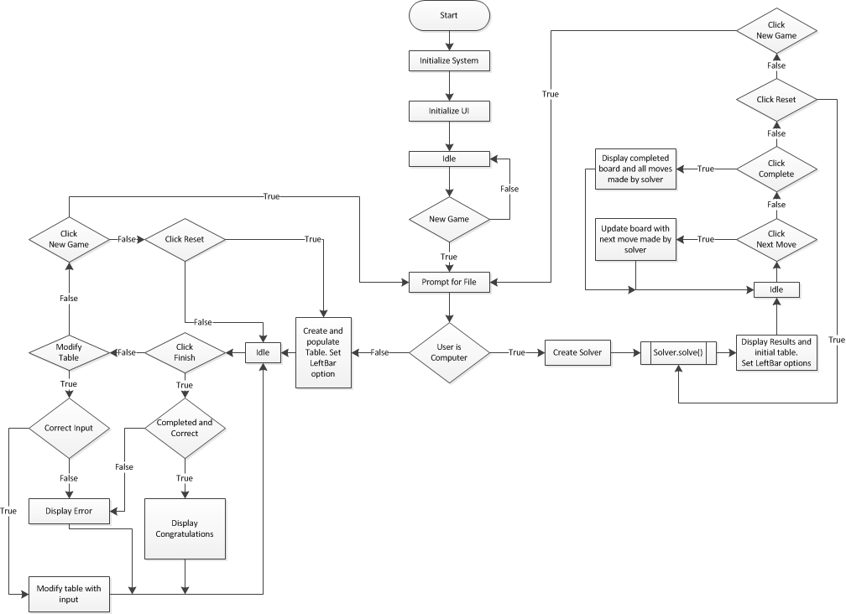

* 1. Solver

The below flowchart is a high level representation of the steps taken by the Solver class to attempt to find a solution to the Numbrix grid.

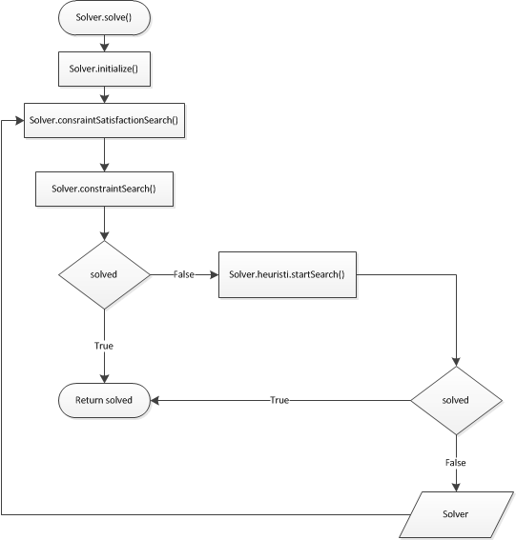

* 1. Solvers Constraint Satisfaction Search

The below flowchart is a more low level representation of the process by which the solver utilizes the ConstraintSearch class via the Solver.constraintSearch() method.

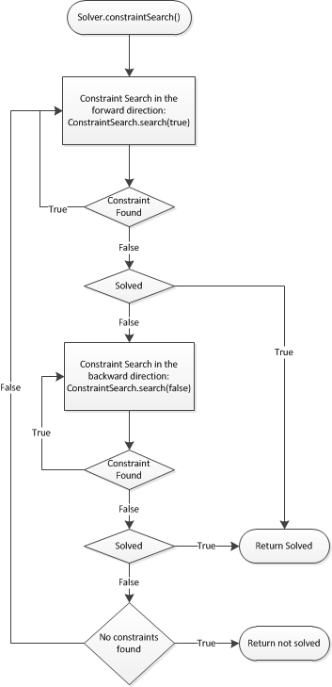

* 1. Constraint Search’s Search Method

The below flowchart is a low level representation of how the ConstraintSearch class attempts to find constraints in a Numbrix grid and by extension find new nodes based on those constraints.

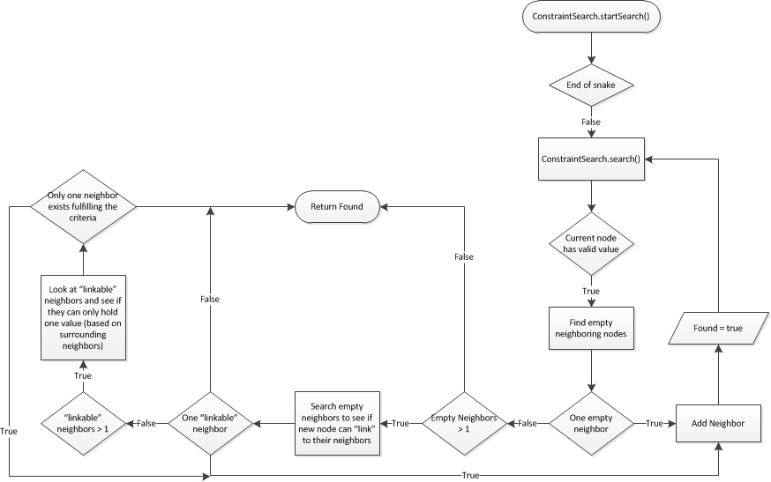

* 1. Heuristic Search’s Search mehtod

The below flowchart is a low level representation of how the HeuristicSearch class attempts to perform a mixture of a brute force search and constraint search (via the Solver class) to find a solution to the Numbrix grid.

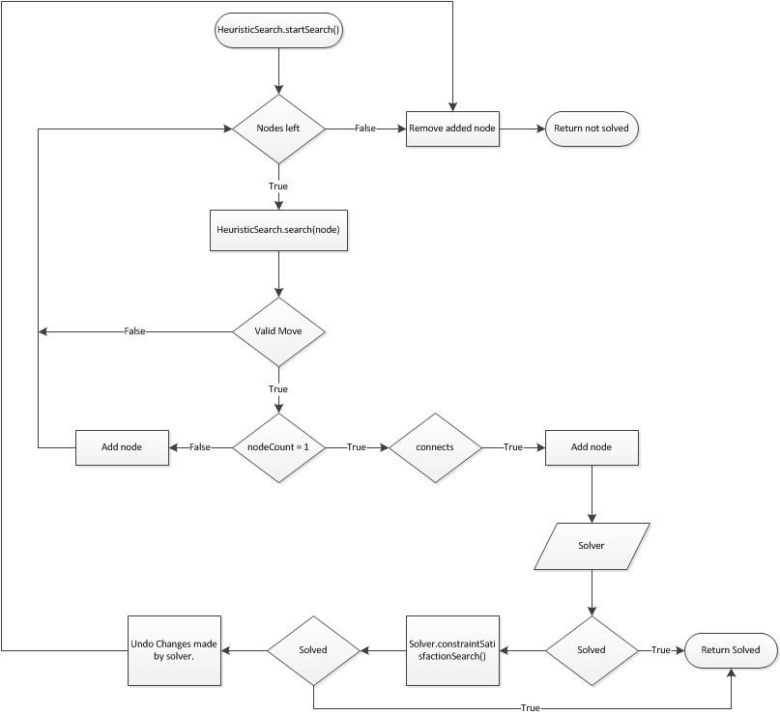

1. UML

The UML diagrams in this section will be sorted by package so as to maintain a level of coherence and simplify the structure of the program. However, a UML diagram of the entire program is presented below so that a basic understanding of the interconnections between structures can be seen.

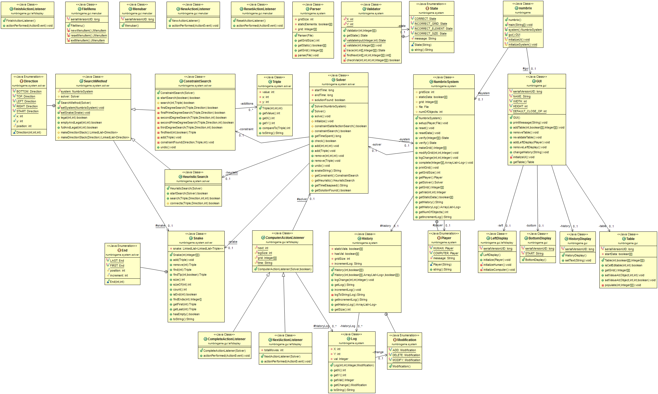

* 1. numbrix

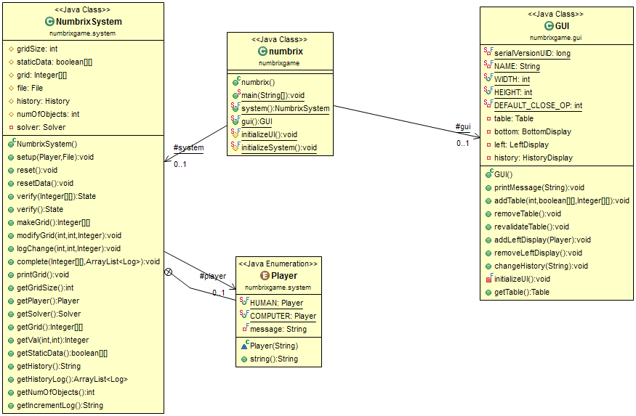

* + 1. gui

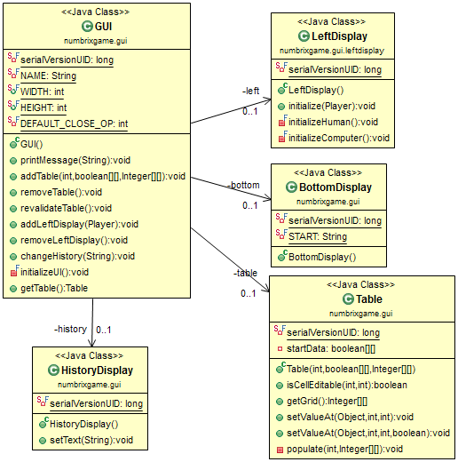

* + - 1. leftdisplay

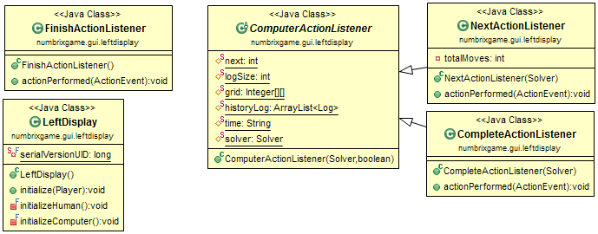

* + - 1. menubar

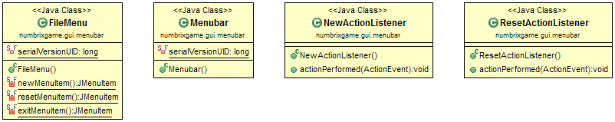

* 1. Numbrix.System

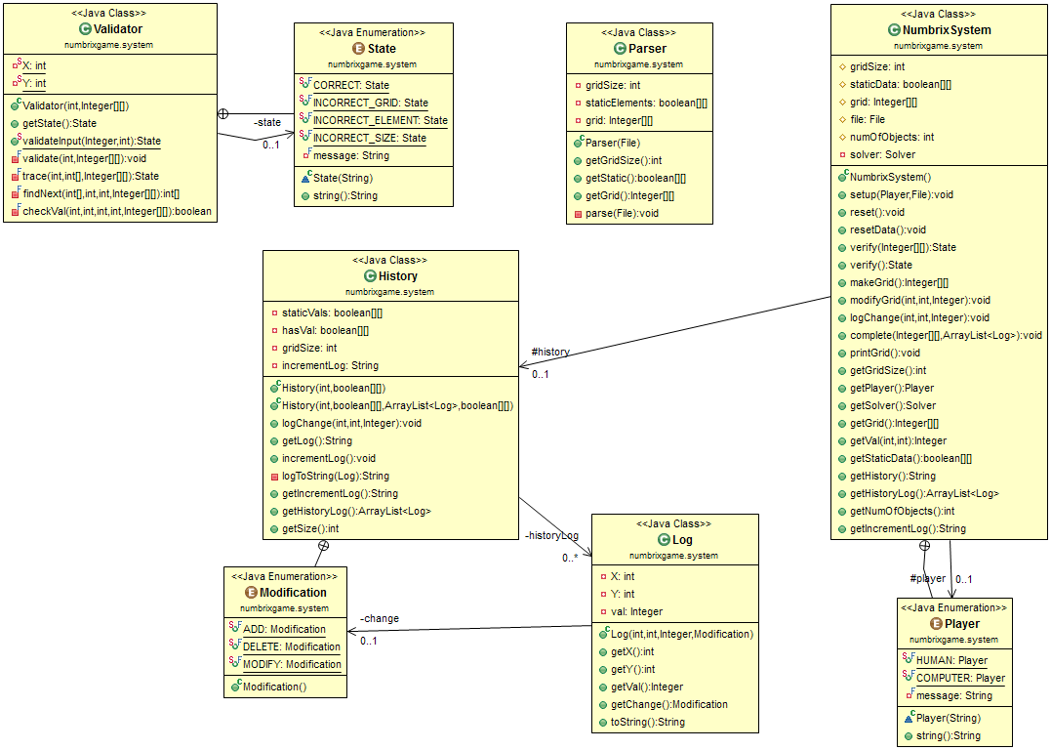

* + 1. solver

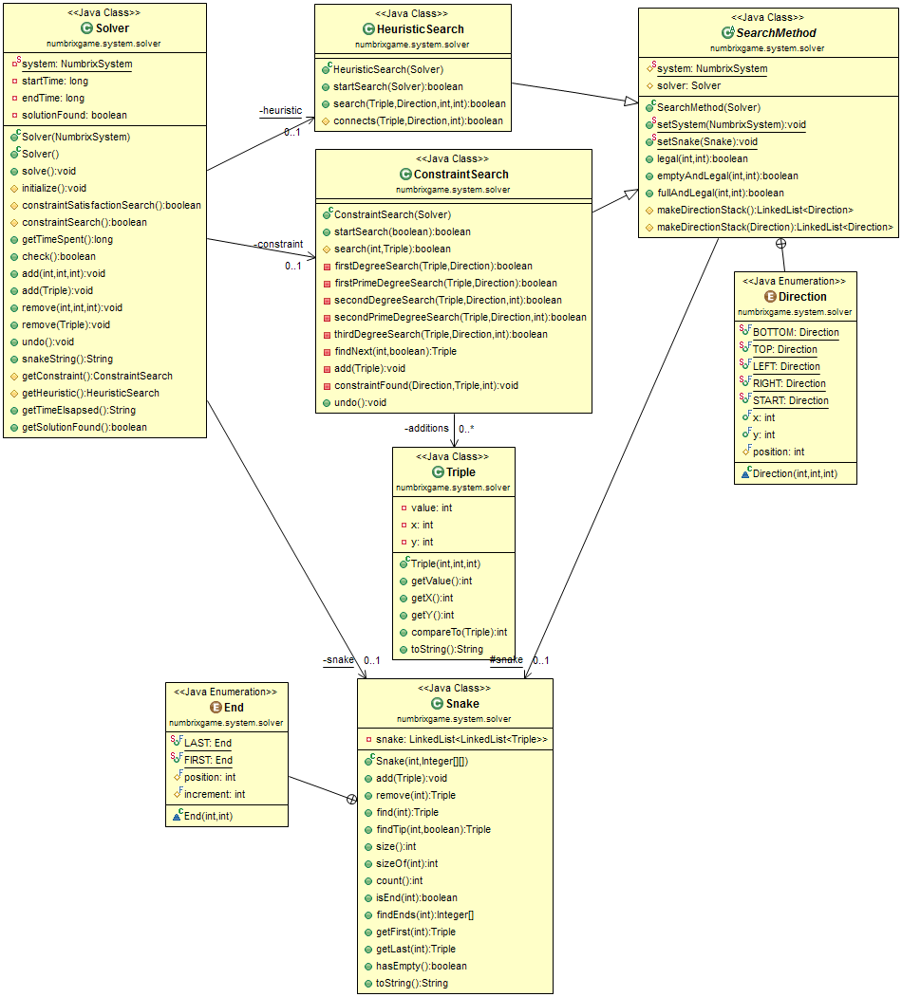

1. Description of Intelligence Implemented

The Solver can be broken down into three parts: the Solver class, the ConstraintSearch class, and the HeuristicSearch class. However, one of the most important parts to this program is the Snake class. Each of these four classes will be discussed below with an explanation of how they contribute to obtaining a solution to a Numbrix grid and any basic intelligence behind each class.

* 1. Snake

The Snake class is a data structure that keeps track of the nodes that have been “found” or “guessed”. It does so by keeping a LinkedList of LinkedLists that hold Triple data structures. A triple is a simple data structure that simply holds the value of a node, the x coordinate of a node, and the y coordinate of a node. The important part here is the LinkedList of LinkedLists which is stored in a variable aptly named snake. Specifically, the Snake class will only store consecutive nodes (based on value) in a single LinkedList. Should a new node that does not consecutively follow or head another node in the snake variable, a new LinkedList will be created to hold the new node. Similarly, should a node be removed from a LinkedList such that it breaks the consecutive pattern of the list, snake will break the broken LinkedList into two LinkedLists that only contain consecutively increasing nodes.

It is also important to note that the LinkedLists are stored in ascending order. This makes insertions, deletions, and searches for particular nodes easier and faster to do. Specifically, a search takes O(N) time to search. This is especially important because it makes it easy and quick to find the heads or tails of particular lists as well as find lists and nodes with the shortest gap between them.

* 1. Solver

The Solver class is rather simple in nature. Its main purpose is to drive the ConstraintSearch and HeuristicSearch classes. However while it may not do much, it is this class that encapsulates the search method of the program. Solver utilizes the constraint satisfaction approach to find a solution to the Numbrix grid. This is done by first applying ConstraintSearch in a forward direction until no more constraints can be found. Once no more constraints can be found, the solver attempts to apply ConstraintSearch in a backwards direction until no more constraints can be found. It repeats this forward and backward search until no more constraints can be found. This repetition is done based off the hope that a new node found by a constraint will reveal new constraints that were not apparent beforehand. Once no more constraints can be found, the solver relies on the HeuristicSearch class to look for more nodes in the grid. More detail on the constraint search itself can be found in part c of this section.

Once the HeuristicSearch starts its search, the solver object is done. However, as soon as the HeuristicSearch finishes its search and no solution has been found, the HeuristicSearch will create a new instance of Search and call the new instances constraintSatisfactionSearch() method. This call brings the Solver class and HeuristicSearch together into this recursive call. Until a solution can be found, HeuristicSearch will continue to create a new solver and call its constraintSatisfactionSearch method which will in turn call HeuristicSearches startSearch method. One subtle difference you may notice is that HeuristicSearches search is called from a static context whereas a new instance of solver is created every time HeuristicSearch finishes searching. This is partly an attempt to conserve memory. However, there is one more key reason for the utilization of a new solver. This will be discussed in part d of this section.

* 1. Constraint Search

The ConstraintSearches search method utilizes three important constraints when looking for the placement of a new node. However, before moving on to these techniques, one important concept must be covered first. It is here where the Snake class shines. When searching for a new node, one must first ask which node to look for. It is unnecessary to look for nodes that have a consecutively larger and a consecutively smaller node next to it. This is because all the nodes that this example node needs have already been found. Hence, because the Snake class keeps lists of only consecutively connected nodes, one can simply use the snake to find the first and last elements of each list in order to create a pool of nodes to search through. This is where the idea of forward and backward searches comes into play. A constraint search in the forward direction is simply a constraint search where the search starts with the last element in a list and progresses to the next lists last element until the final list is reached. Similarly, a constraint search in the backwards direction starts with the first node in the last list of the snake and works its way to the first node in the first node of the list.

The constraint search thus takes a node (A) from the tip of a list in the snake and looks for its neighbors. This is where the three constraints come into play. First, the search will look for all empty and legal neighboring nodes surrounding A. A legal node is one that is not placed out of the bounds of the grid. A neighbor is any node that is directly on top of, under, to the right of, or to the left of a node. If there is only one empty and legal node next to A, then it must be the case the empty node holds the value that is the increment of A or decrement of A if going in the forward or backwards direction respectively.

If, however, there is more than one empty legal neighboring node, this claim cannot be made. Hence, the next constraint comes into play. This second constraint looks at the two empty neighboring nodes and checks to see if these nodes are neighbored by a legal and populated node that has a value equal to double the increment (or decrement) of node A. This means that the populated neighboring node can act as a hint as to whether or not the empty node can “connect” node A and the populated node. If there exists only one empty node that can “connect” node A and the populated node, then it must be the case that the empty node contains the incremented (or decremented) value of A. Note that the only time two empty nodes will be capable of this “connection” are when the node A and the populated node are diagonally adjacent to each other.

If it is the case that there exists two empty nodes that can “connect” A and the populated node, then ConstraintSearch applies one final constraint. In this final constraint, ConstraintSearch once again looks at the neighbors of the remaining empty nodes and checks to see what values the empty node can hold. If it is the case that there exists only one empty node than can “connect” only one pair of nodes together, then it must be the case that this single empty node must hold the increment (or decrement) of A.

* 1. Heuristic Search

Once the HeuristicSearch starts its search, the solver has given up on finding “sure” answers and takes a brute force approach to the solution. However, that is not to say the solver completely relies on guesses from here on out. This search starts, once again, with the Snake object. HeuristicSearch will find, from the Snake, the two nodes that have the shortest gap from each other. It will then attempt to bridge this gap. The reasons for this are two fold. First, because the solver will be making guesses, it would be better to make the smallest number of guesses possible. Hence, the smallest gap is chosen to be filled in. Second, this search utilizes a depth first search and it is quicker to do a depth first search with a shorter known distance than a longer one.

So, given a starting node with a known distance, HeuristicSearch attempts to find a path to the next node in the snakes list. It does so by taking a node and searching it’s neighbors (in an arbitrary order). If the neighbor is empty and legal, it will then perform the search. Hence, HeuristicSearch utilizes a recursive search method to look for a path that connects to the head of the next list in the snake. If no more paths can be taken, the method will simply terminate and move on to the next neighbor. Once the node count has reached one and the correct neighbor is found, HeuristicSearch creates a new solver and calls its constraintSatisfactionSearch. The reason for creating a new instance of solver is so that it can create a new instance of ConstraintSearch. This is because there is a possibility that the search will prove impossible with the given guessed path and so the HeuristicSearch will need to back track and remove any changes made.

While it is easy to remove and add changes from the HeuristicSearch due to its recursive nature, additions made by ConstraintSearch are not so easy to keep track of. Hence, by creating a new instance of ConstraintSearch and having each instance keep track of its changes while also only having each instance perform a search and make changes between heuristic searches, it is possible to keep track and undo changes made by the ConstraintSearch class. Thus, once a HeuristicSearch finds that it can no longer progress any further down a given path, it tells its solver to undo changes made by the ConstraintSearch and then the HeuristicSearch undoes the node it added at its given search method. By taking this approach, the Solver should be able to cover every plausible path (brute force) while cutting out unnecessary paths in the process by doing a combination of guessing and constraining on the grid.

1. What I Would Have Done Differently

One of my major gripes with the project were in fact minor mistakes made on my part. Small logical errors and bad implementations of code were rampant. Among these mistakes was my forgetting the coordinate convention. When creating the solver, I used one convention for coordinates and when creating the first part of the project I used a different convention. This led to some initially confusing output when I attempted to combine the solver and the Numbrix system. My one other issue with my project is the structure of my system (everything other than Solver). Towards the end, it felt like I was hacking together my code in order to get certain output to display correctly. In hind sight, I would like to have had the chance to remake the system and increase the separation between the GUI and the System classes while creating well defined access to different elements of the program.

Thankfully, there is not much I am unhappy with in regards to the solver. If I had time, I would like to have looked for and implemented more constraints in the ConstraintSearch class. I would also like to have added a bit more intelligence in the HeuristicSearch so as to weed out more bad paths before taking them. Most notably, I noticed that when creating a new connection between nodes, it was possible to create “islands”. That is, there were times when combining nodes that two or more separate empty areas would be made. After forming this connection, instead of continuing to apply constraints and heuristic searches until it is impossible to do so, I could instead weed out the path entirely (and save much time) by checking to see if the islands were fillable. That is, if the borders of the islands only contained non-tip nodes from the snake, then it would be impossible to fill them. Hence, I would know right then that the path I created was a bad path. There are other constraints I could use to check the islands as well, but the important thing of note is that one could use this concept of islands to help prune bad paths from the search as opposed to taking the bad path and every branch along the bad path.